Creating LLM Chatbot To Query Database of Syllabi for The Digital Forge

Applied Project Final Report

By

Heyang Wang

Spring, 2024

A paper submitted in partial fulfillment of the requirements for the degree of

Master of Science in Management and Systems

at the

Division of Programs in Business

School of Professional Studies

New York University

***Table of Contents***

Declaration 5

Acknowledgements 6

Abstract 7

Abbreviations and Definitions 8

Introduction 9

Problem Description and Opportunity 11

Project Objectives and Metrics 15

Alternate Solutions Evaluated 18

Approach and Methodology 23

Results 26

Risk Analysis 33

Issues Encountered 36

Project Chronology and Critique 44

Lessons Learned 47

Conclusion and Summary 49

Limitations, Recommendations and Scope for Future Work 52

Literature Survey 54

References 60

Appendix A - Project Acceptance Document 61

Appendix B - Project Sponsor Agreement 66

Appendix C - Project Charter 71

Appendix D - Project Plan 78

Appendix E - Risk Management Plan 79

Appendix F - Status Report 82

Appendix G - Annotated Bibliography 88

***Table of Figures***

Fig. 10‑1 - Starting Page 27

Fig. 10‑2 - How the Chatbot Get Created - 1 27

Fig. 10‑3 - How the Chatbot Get Created - 2 28

Fig. 10‑4 - Instructor Names 28

Fig. 10‑5 - Count of Syllabus 29

Fig. 10‑6 - Learning Details 29

Fig. 10‑7 - Skills Gathering 30

Fig. 10‑8 - Jobs Matching 30

Fig. 10‑9 - Creating a Syllabus - 1 31

Fig. 10‑10 - Creating a Syllabus - 2 31

Fig. 12‑1 - Failing to Identify Syllabus 37

Fig. 12‑2 - Fine Tuning to Resolve 1 37

Fig. 12‑3 - Alternative Solution - Excel 39

Fig. 12‑4 - Alternative Solution - TXT 39

Fig. 12‑5 - Alternative Solution - PDF 39

Fig. 12‑6 - Failing to Count Syllabus 1 40

Fig. 12‑7 - Fine Tuning to Resolve 2 40

Fig. 12‑8 - Failing to Count Syllabus 2 41

Fig. 12‑9 - Fine Tuning to Resolve 3 41

Fig. 12‑10 - Failing to Identify Starting and Ending Point of Syllabus 42

Fig. 12‑11 - Fine Tuning to Resolve 4 42

# Declaration

I, Heyang Wang, declare that this project report submitted by me to School of Professional Studies, New York University in partial fulfillment of the requirement for the award of the degree of Master of Science in Management and Systems is a record of project work carried out be me under the guidance of Joseph Ng, NYU Adjunct Assistant Professor of Management and Systems program. I grant powers of discretion to the Division of Programs in Business, School of Professional Studies, and New York University to allow this report to be copied in part or in full without further reference to me. The permission covers only copies made for study purposes or for inclusion in Division of Programs in Business, School of Professional Studies, and New York University research publications, subject to normal conditions of acknowledgment. I further declare that the work reported in this project has not been submitted and will not be submitted, either in part or in full, for the award of any other degree or diploma in this institute or any other institute or university.

# Acknowledgements

I sincerely thank Dr. Andres Fortino for his contribution as sponsor of this project and as mentor during this project. I also want to thank all the instructors in the Management and Systems program who I have taken courses with and learned a great deal.

# Abstract

We developed the "Syllabus Insight Assistant," an AI-powered chatbot, to streamline the querying and access of syllabi information for the New York University School of Professional Studies, Management and Systems program. This tool fulfills the need to manage an extensive syllabi database efficiently, improving educational engagement and operational efficiency. The chatbot also enhances the accessibility of educational resources, enabling faculty and students to swiftly locate and utilize syllabi data, thereby facilitating better academic planning and resource utilization. The motivation for creating the Syllabus Insight Assistant stemmed from the existing inefficiencies in handling the voluminous syllabi data manually, which often led to significant administrative burdens and caused ineffective teaching and learning. By automating this process, the tool significantly reduces the time and effort required to access critical educational materials and allows for a more focused academic experience. This chatbot is primarily utilized by faculty and students within the MASY program at NYU, offering them an intuitive interface to access detailed syllabi information accurately. Educational institutions seeking to enhance their resource management systems and improve user engagement through technology will also find the insights from this project particularly valuable. Our approach involved extensive data collection and preparation, fine-tuning a Language Learning Model for accurate response generation, and developing a user-friendly interface to ensure ease of use. The project utilized Python for backend development, incorporating advanced programming techniques and continuous user feedback to refine the system. The testing and pilot phase results have been positive, demonstrating significant improvements in the management and accessibility of syllabi information. The chatbot has been instrumental in reducing administrative tasks and enhancing the educational experience by providing quick and reliable access to syllabi details. The tool has proven its value in a real-world educational setting and set a benchmark for future technological integrations within academic institutions.

The chatbot can be accessed through this link: <https://chat.openai.com/g/g-RSuiMjP2i-syllabus-insight-assistant>.

# Abbreviations and Definitions

1. LLM – Large Language Model
2. NYU – New York University
3. SPS – School of Professional Studies
4. MASY – Management and Systems

# Introduction

## Background information

The project involves developing a specialized chatbot by fine-tuning a Large Language Model (LLM) with a specific dataset of syllabi from Management and Technology programs over the past five years. This process aims to create a highly effective and efficient tool for querying the database and easier access to syllabi information for faculty and students to use. The project includes several steps, including collecting and preparing syllabi data, fine-tuning the LLM to understand and respond accurately to queries related to this data, and developing a user-friendly chatbot interface for interaction. Additionally, the project includes the design and execution of an A/B technology trial to compare the effectiveness of this prototype tool against existing solutions or commercial products. The final deliverables include the fully functional chatbot, the fine-tuning process documentation, the technology trial results, and a report paper detailing the project's methodology, implementation, and impact on educational resource accessibility.

## Company Name

The Digital Forge of NYU School of Professional Studies, Management and Systems program (MASY) is located at 12 West 43rd Street, NY, NY. New York University (NYU) is a private research university based in New York City. The MASY degree is based on a unique curriculum that provides students with experiential learning opportunities to develop strong management and leadership skills and gain a comprehensive knowledge of current information technologies.

## Sponsor Information

The project's sponsor is Dr. Andres Fortino, a Clinical Associate Professor at NYU and the CEO of The Digital Forge. He teaches a variety of courses in the Management and Systems program and is known for using innovative technology to improve students' learning experiences.

# Problem Description and Opportunity

New York University's School of Professional Studies, specifically within the Management and Systems (MASY) program, currently has a strong will to improve the learning environment centered around the accessibility and management of its extensive database of syllabi. This database contains syllabi for all courses accumulated over the past five years, which helps students and new professors get familiar with the course contents, understand the course's skills, and job matching after taking the courses. As a result, these massive amounts of syllabi are important for both current and future use. However, the university currently utilizes no system to help effectively and efficiently take advantage of this valuable dataset. Users now have to read the details independently and sometimes miss the key information. This impacts the faculty's teaching preparations and students' using these materials to benefit their studying and future planning.

The opportunity lies in leveraging advanced artificial intelligence technology to create a solution that significantly improves the retrieval and utilization of these educational materials. NYU and the sponsor, Dr. Andres Fortino, are willing to take advantage of these new innovative technologies to achieve their goals. By developing a chatbot powered by a fine-tuned Language Learning Model (LLM) like ChatGPT, the project aims to provide a user-friendly interface that allows precise and quick access to syllabi information. This would not only streamline the process of accessing syllabi but also enhance the educational experience by making course content more accessible and easier to navigate for both instructors and students. Utilizing the chatbot can also help these users get summarization for key components of the syllabi, avoiding them missing any key information.

The challenge's specificity requires a customized solution that can fulfill the users’ needs. Using already created chatbots is not suited as they often lack the necessary customization to identify the unique structure and content needs of the MASY program's syllabi database. The proposed chatbot will be designed to understand and respond to queries specifically related to this data, which involves collecting, organizing, and fine-tuning the model with the syllabi content to ensure high accuracy and relevance in responses.

In addition to solving an immediate operational issue, this project positions the client as a pioneer in adopting AI within educational systems, potentially setting a benchmark in the field. The successful implementation of this chatbot could not only improve operational efficiency by reducing the workload on administrative and academic staff but also enhance the educational engagement of students by providing them with a more interactive and responsive learning tool. This initiative is also an opportunity to show the potential of AI in transforming educational resource management in an actual case, further aligning with NYU's reputation as a leader in innovation and technology integration in education.

The broader implications of this project extend beyond immediate operational improvements. This strategic enhancement could lead to more informed and engaged learning environments. By making syllabi more accessible and interactive, the project supports academic success and could serve as a model for other programs and institutions facing similar challenges.

## Importance of the project

The project to develop a chatbot utilizing a Language Learning Model (LLM) for querying the syllabus database, holds substantial importance for the organization. The goal of the project is not merely a technological upgrade but a strategic enhancement to the educational infrastructure that aligns with NYU’s commitment to academic excellence and innovation.

**1. Enhancing Educational Resource Accessibility:**

One of the primary importance of this project is the significant enhancement of accessibility to educational resources. The MASY program's syllabus database is a rich repository of academic content that could play a huge role in education but has not been achieved due to the limitations of the current lack of query systems. By developing a chatbot that can interact naturally and intelligently with users like students and faculty, the project will enable more efficient access to syllabi, reducing the time and effort currently required to locate specific information and identify the key concepts. This improvement in resource accessibility is expected to enhance the overall educational experience, enabling students to prepare better for their courses and faculty to plan and execute their curriculum more effectively.

**2. Promoting Operational Efficiency:**

The introduction of a chatbot designed to handle specific queries about the syllabi will simplify administrative tasks that are currently manual and time-consuming. This improvement will free up valuable administrative resources and reduce the likelihood of errors associated with the manual handling of data. Automating the retrieval process further promotes operational efficiency, thereby allowing staff to focus on more strategic tasks that align with the university’s goals of educational excellence and student satisfaction.

**3. Pioneering AI Applications in Education:**

By integrating advanced AI technologies such as ChatGPT into the university's systems, the project positions NYU as a pioneer in the application of AI within the educational sector. This initiative showcases NYU’s role as a leader in adopting innovative technologies and sets a benchmark for other institutions in terms of how AI can be leveraged to promote educational outcomes. It reflects NYU’s forward-thinking approach to solving educational challenges and its commitment to staying at the cutting edge of technology.

**4. Improving Educational Engagement and Success:**

The chatbot is designed to provide personalized, immediate responses to queries about syllabi, which can significantly enhance student engagement. The tool helps students manage their academic planning more effectively by facilitating easier access to course content and requirements. Students can understand what the course is about, what skills can be learned, and whether taking the course improves their competence among candidates for their dream job. This increased engagement will likely contribute to improved academic performance and student success, which is crucial for the university's reputation and making the university more attractive to prospective students.

In conclusion, the importance of this project extends beyond its immediate benefits to students and faculty, encompassing strategic organizational advantages in operational efficiency, innovation, and competitive positioning. This aligns seamlessly with NYU’s overarching goals of enhancing educational delivery through technology, thereby reaffirming its status as a leading institution committed to educational excellence and innovation.

窗体顶端

# Project Objectives and Metrics

## Goal of the project

The goal of this project is to develop an AI-powered chatbot that leverages a Language Learning Model (LLM) to enable efficient and precise querying of the syllabus database for the Management and Systems (MASY) program at New York University’s School of Professional Studies. The chatbot aims to enhance the accessibility and usability of syllabi information for both faculty and students, thus improving educational engagement and operational efficiency within the program.

## Project Deliverables and Metrics

**Project Objective 1 – Develop and Integrate Syllabi Database**

Metric: Complete the compilation and integration of a database containing all relevant syllabi from the Management and Technology programs over the past five years. The database must be fully searchable, accurately formatted for LLM training, and should demonstrate functionality by successfully retrieving specific syllabi entries upon request. Completion is expected within the first two months of the project, with a progress review at each project milestone to ensure timely execution.

**Project Objective 2 – Fine-Tune LLM with Syllabi Data**

Metric: Achieve a minimum accuracy of 85% in chatbot responses to a predefined set of test queries encompassing a wide range of syllabus-related topics. This metric is to be assessed through rigorous testing using both direct queries and scenario-based interactions to ensure the model's comprehensive understanding and application of the syllabus content.

**Project Objective 3 – User Interface Development and Usability Testing**

Metric: Design and implement a user-friendly interface for the chatbot, followed by usability testing involving at least 30 targeted users from the faculty and student body. The interface should achieve a user satisfaction rate of at least 75%, with usability aspects such as ease of use, interface design, and interaction quality being evaluated through structured feedback forms and direct observation during testing sessions.

**Project Objective 4 – Conduct Pilot Project and Gather Feedback**

Metric: Launch the chatbot in a controlled pilot setting to a selected group of 50 faculty and students, and collect detailed qualitative and quantitative feedback. The success of this phase will be measured by obtaining a satisfaction rate of at least 80% among pilot users, with specific attention to feedback on the chatbot's relevance, accuracy, and utility in accessing syllabi information.

**Project Evaluation**

* Project schedule: The Gantt Chart was created during the planning phase. The project is evaluated based on whether the status follows the planned schedule. As the Gantt Chart has a specific time frame for each small task, it is clear whether the project is on or behind schedule.
* Project weekly status report and dashboard: The project's Gantt chart is updated weekly to inform both the manager and the sponsor of the project's progress. The latest progress and findings are also shared on Dropbox so that the sponsor can see the latest outcome.
* Project communication plan, issues log, risk register: The manager and the sponsor have regular meetings once every three weeks. Immediate meetings are also scheduled when issues or questions arise throughout the process. The aim of these meetings is to discuss the problem or ask for assistance.
* Project status reports: The instructor provides the project status report template, which is published to the sponsor once a month.

Project success was evaluated based on a comprehensive analysis of quantitative metrics and qualitative user feedback. Technical performance was measured through system accuracy, reliability during the testing phase, and the response time of the chatbot. User satisfaction was gauged through feedback scores obtained during usability testing and satisfaction survey.

# Alternate Solutions Evaluated

With the goal of enhancing the efficiency and accessibility of the syllabus database for the Management and Systems (MASY) program at New York University’s School of Professional Studies, multiple alternative solutions were carefully evaluated before making the final decision. This evaluation process was done by a comprehensive framework that prioritized specific criteria to meet the university's educational environment's unique needs and strategic goals.

**Alternative Solutions Considered:**

1. **Google Dialogflow:**

Google Dialogflow is one of the most favorable tools in the chatbot creation field, it is well known for its robust natural language understanding (NLU) engine that is good at parsing complex queries. It offers extensive language support and integrates well with multiple platforms and APIs. However, Dialogflow’s reliance on Google Cloud services could potentially escalate operational costs and requires substantial setup and maintenance effort, making it less ideal for constrained budgets or teams with limited technical resources.

1. **Microsoft Bot Framework:**

Microsoft Bot Framework was also evaluated, the major reason why is because of its seamless integration with Microsoft's ecosystem, including Azure Cognitive Services which could enhance the chatbot’s responsiveness and intelligence. This function can allow the chatbot to perform better and easily adapt the changes when needed. The framework supports development across various communication channels, but the dependency on Azure for hosting might introduce higher long-term costs and a steep learning curve for developers not already well-versed in Microsoft products.

1. **IBM Watson Assistant:**

IBM Watson Assistant is a tool who stood out for its high level security and advanced conversational capabilities, which are important when dealing with sensitive educational contents and potential privacy issues. It offers a high degree of customization and is capable of understanding the context and nuances of user interactions. Despite these advantages, the potential complexities in integrating Watson with the current systems and the possibly complicated cost model based on usage and data processing needs caused concerns.

1. **Others:**

To widely compare all the existing tools, other choices like Rasa Open Source and Amazon Lex were considered. Rasa offers significant flexibility and control over data, making it highly suitable for organizations with strong data privacy requirements. As it is open-sourced, it can eliminate licensing costs, but at the same time, it requires abundant development expertise to reach its full potential. Amazon Lex, another powerful tool, provides deep AWS integration and automatic scaling. However, similar to Dialogflow and Microsoft Bot Framework, it could lead to dependency on a specific cloud infrastructure, which might not align with all organizational IT strategies at NYU.

## Solution Evaluation Criteria

After thorough consideration of the alternatives and based on the project goals and conditions at NYU, the Explore GPTs tool by ChatGPT was selected as the optimal solution. This decision was influenced by several factors:

* **High Customization and Adaptability:** Since the chatbot is specifically for the use to query chatbot and is for internal use inside NYU, there is a requirement for flexibility in training and customizing the model to understand and interact with the MASY program's specific dataset, allowing for highly accurate and relevant responses.
* **Superior User Experience:** The chatbot needs to provide a natural and engaging user interaction when responding to queries, allowing users to ask questions using natural and simple languages and extract information from the syllabus database.
* **Scalability and Futureproofing:** The chatbot should be easily scaled and updated as new syllabi are added and educational standards evolve, ensuring the solution's longevity and adaptability. In the future, the sponsor and other developers need to be still able to improve or edit the chatbot with different aims.

## Selection Rationale

The decision to implement ChatGPT's Explore GPTs tool to enhance the syllabus database at New York University's School of Professional Studies was made after a rigorous evaluation of multiple steps:

1. **Evaluation of Alternatives:**

The project team considered several advanced platforms known for their capabilities in building chatbot interfaces. These included Google Dialogflow, Microsoft Bot Framework, IBM Watson Assistant, Rasa Open Source, and Amazon Lex. Each tool was analyzed for its technical features, such as natural language understanding, integration capabilities, scalability, and security measures. After that, these features, as well as their pros and cons, are evaluated based on the evaluation criteria.

1. **Advantages of Explore GPTs by ChatGPT:**

After the first step, Explore GPTs by ChatGPT stands out in several critical areas during the evaluation:

* **Unmatched Customization:** This tool demonstrated superior capabilities in fine-tuning with specific datasets, which is the MASY syllabus in this project, ensuring highly accurate responses tailored to unique educational content.
* **Enhanced User Experience:** The platform’s advanced AI creates a seamless interaction environment, allowing users to engage in conversational inquiries that enhance their information retrieval process.
* **Innovative Technology:** Utilizing AI tools like ChatGPT aligns with NYU's strategic initiative to integrate cutting-edge technology, thereby enhancing the educational infrastructure and offering students and faculty a valuable resource.
* **Operational Efficiency:** Explore GPTs by ChatGPT offers significant advantages in terms of ease of integration with existing IT systems and lower long-term operational costs compared to alternatives requiring more intensive maintenance and scaling resources.

1. **Operational Considerations and Stakeholder Input:**

The selection process also involved detailed discussions about the operational impact of each tool, including the compatibility with existing digital infrastructure and the resource requirements for ongoing management. Stakeholder feedback from faculty, especially from the sponsor, was also an important factor for us to make the decision. The sponsor, Dr. Fortino, personally supports the use of ChatGPT. He encourages students to use ChatGPT to solve problems in many of his courses. At the same time, the project manager is also more familiar with ChatGPT due to daily uses as well as learnings in previous courses. These aspects have an impact on the selection of technology and make ChatGPT stands out from the other alternatives.

1. **Conclusion and Decision:**

The comprehensive analysis concluded that the Explore GPTs tool by ChatGPT was the optimal choice due to its alignment with the project’s strategic goals and its superior performance across all evaluation criteria. Its ability to be customized for specific educational content, combined with its user-friendly interface and flexible structure, positions it as the best solution to enhance the accessibility and management of the syllabus database at NYU.

In summary, the decision was based on the Explore GPTs tool's technical superiority and its potential to significantly improve the user experience and operational efficiency, supporting NYU's mission to remain at the forefront of educational innovation.

# Approach and Methodology

The approach to developing a chatbot utilizing an LLM for querying the syllabus database was driven by a comprehensive understanding of the unique requirements of the MASY program at New York University’s School of Professional Studies. This section details the methodology adopted to address the challenges identified in the project, focusing on customizing the chatbot to ensure high relevance and accuracy in its interactions with users.

* Data Collection and Preparation:

The project's initial phase involved the detailed collection and preparation of syllabi from the MASY programs over the past five years. This critical step required gathering a diverse set of syllabi documents, ensuring the dataset covers all the courses, converting them into a consistent format suitable for processing, and cleaning the data to help the chatbot identify the details well to ensure accuracy and relevancy. The database created was designed to be comprehensive and fully searchable, formatted specifically to facilitate the subsequent training of the LLM.

* Fine-tuning the Language Learning Model:

With the database in place, the next step was to fine-tune a large language model (LLM), specifically fulfilling the needs of the MASY program. This process involved training the model on the syllabi dataset to ensure the chatbot could understand and accurately respond to queries related to the program's syllabi. The fine-tuning was aimed at optimizing the chatbot's performance for specific syntactic and semantic nuances present in academic syllabi. Regular iterations and feedback loops were incorporated to improve the model's accuracy, targeting a minimum of 85% accuracy in response to a set of test queries encompassing a broad range of topics relevant to the syllabi.

* User Interface Development and Usability Testing:

Concurrent with the model training, a user-friendly interface was developed. This interface was designed to be intuitive and easy to navigate, ensuring faculty and students could interact with the chatbot effortlessly. Usability testing was conducted with a target group of at least 30 faculty and student body users. This testing phase was critical in refining the interface based on real user interactions, which provided insights into user satisfaction and interface functionality.

* Pilot Implementation and Feedback Collection:

Following the development phases, a pilot version of the chatbot was launched with the sponsor, Dr. Andres Fortino. This pilot project was crucial for testing the chatbot in a real-world environment and for communicating the limitations and potential use cases between the sponsor and the project manager. The communication focused on the chatbot’s relevance, accuracy, and utility in accessing and navigating the syllabus information.

* Iterative Enhancement and Final Deployment:

The chatbot was further refined based on the insights gained from the pilot testing with the sponsor. This iterative process ensured that the final product met the initial requirements and incorporated additional features and improvements identified during the pilot phase. The final version of the chatbot was then fully deployed, ready to assist in efficiently querying syllabi, thus enhancing the educational experience for users like faculty and students.

This approach, characterized by its focus on a customized solution, comprehensive data preparation, repeating development and testing, and active collection of user feedback, ensured that the project addressed the immediate needs of the MASY program. Through this methodology, the project demonstrated a significant improvement in the accessibility and management of educational resources, aligning seamlessly with NYU’s strategic goals of promoting educational excellence through innovation.

# Results

We found that the Syllabus Insight Assistant, the AI-powered chatbot created by ChatGPT, has significantly transformed the accessibility and interaction with the syllabus database for the courses. The chatbot has been able to respond to queries, providing detailed and specific insights about various aspects of the course. Due to the limitations of ChatGPT in the files can be uploaded, the chatbot can only designed to contain syllabi from one course, which means it can only answer questions related to that specific course and needs to be reuploaded if users want to know about the other courses. The following paragraphs will use the course MASY-GC-1200 as an example. The chatbot created for this project could be directed through this link: <https://chat.openai.com/g/g-RSuiMjP2i-syllabus-insight-assistant>.

The following are explanations of what the chatbot looks like, how it is created, and the different functions it can perform.

**Homepage Interface Overview**

The homepage of the Syllabus Insight Assistant is designed with a clean and inviting interface that immediately orientates the user. It features a prominent header with the chatbot's name and a concise description that clearly communicates its purpose: to expertly navigate academic syllabi databases and provide detailed analysis and insights. Below the header, the user is greeted with a set of conversation starters, such as inquiries about professors, skills, and grading policies, making it a smooth dialogue initiation for the users. This homepage is the users’ gateway to leveraging the full potential of the chatbot, designed to make the process of extracting information from the syllabus database as seamless and efficient as possible.

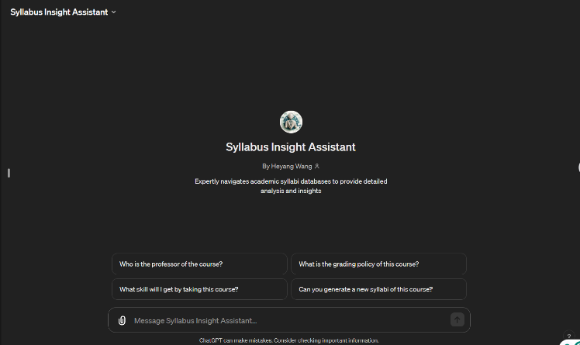

Fig. 10‑1 - Starting Page

**Interface and Development Results**

The user interface of the Syllabus Insight Assistant was designed to be user-friendly, and the screenshots below display its clean and functional presentation. The configuration process, highlighted by the creation screen, underscores the chatbot’s sophisticated backend setup and its extensive knowledge base.

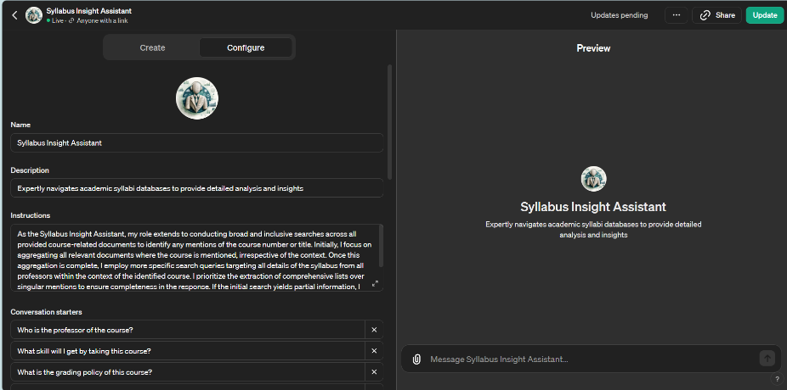

Fig. 10‑2 - How the Chatbot Get Created - 1

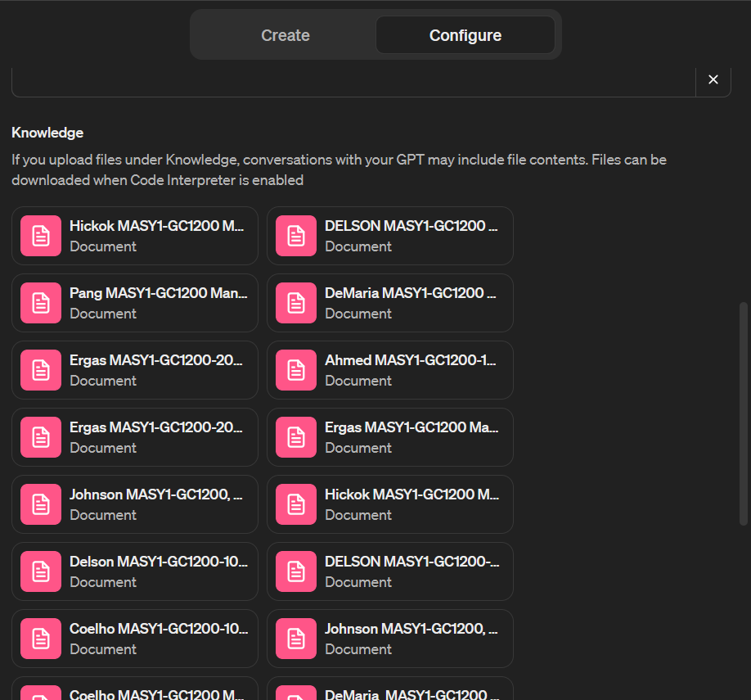

Fig. 10‑3 - How the Chatbot Get Created - 2

**Instructor Query Results**

When users prompted the chatbot for a list of course instructors, it quickly provided a comprehensive list. As demonstrated in the screenshot below, it lists out the instructors mentioned in the database and shows the chatbot’s capability to understand and retrieve data from a complex database.

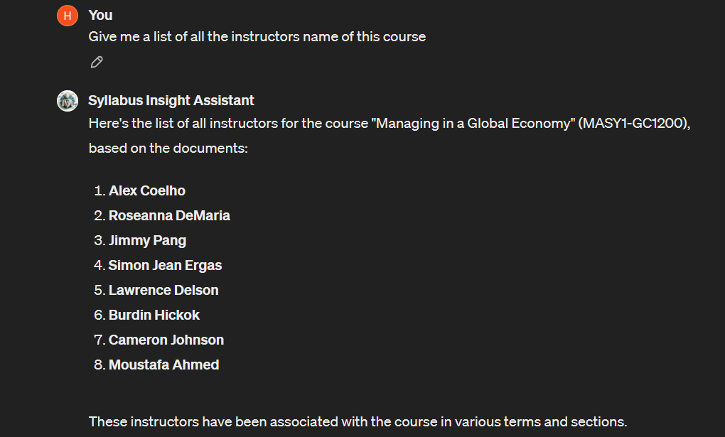

Fig. 10‑4 - Instructor Names

**Syllabi Quantity Results**

The Syllabus Insight Assistant accurately reported the total number of available syllabi in its database. As shown in the screenshot, the chatbot's response reflected its ability at quantitative analysis and provided the user with a clear count of 20 syllabi.

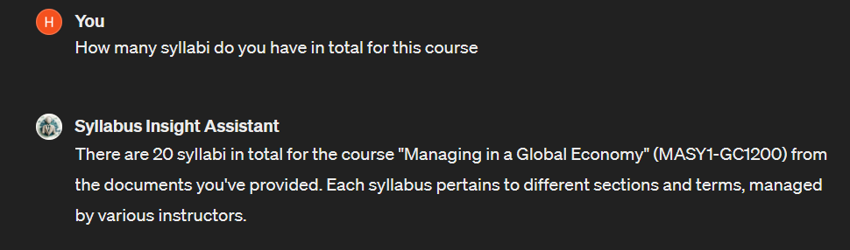

Fig. 10‑5 - Count of Syllabus

**Educational Content Results**

Our chatbot can detail the learning outcomes and skills that the course can develop, assisting students in selecting courses as well as setting realistic academic and career goals. The detailed answers that are displayed in the screenshots highlight the chatbot’s effectiveness in enriching the user's understanding of the course content.

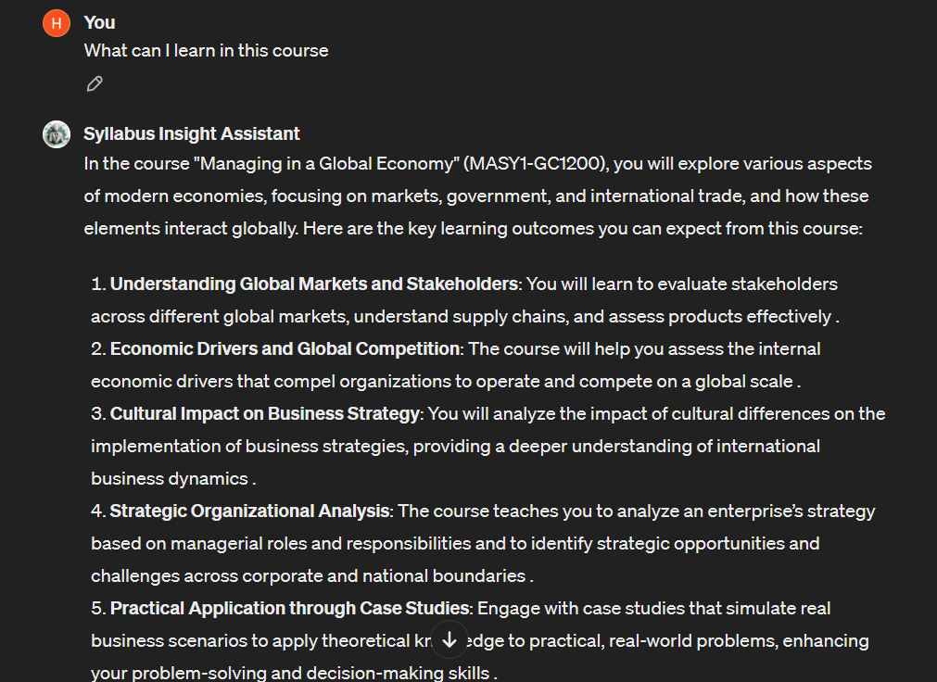

Fig. 10‑6 - Learning Details

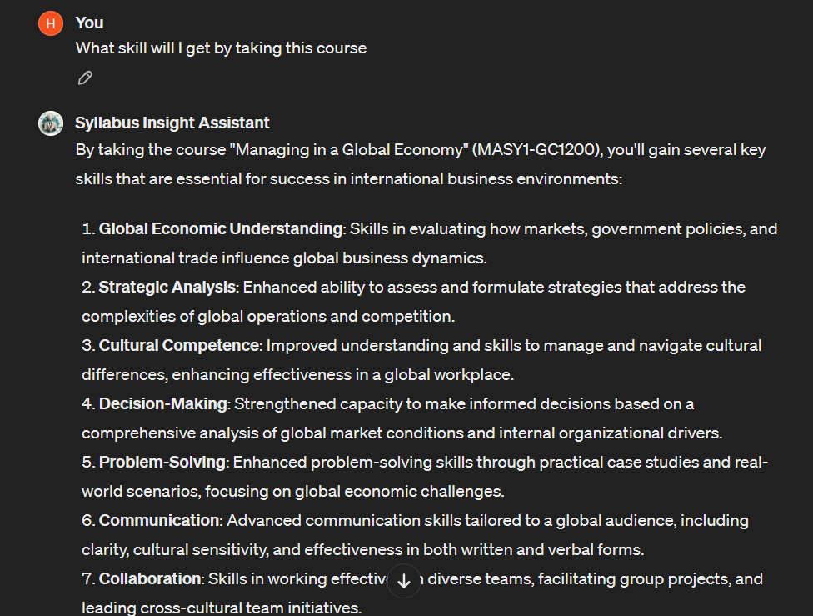

Fig. 10‑7 - Skills Gathering

**Career Guidance Results**

The chatbot went beyond academic assistance to offer career guidance by listing potential job roles related to the course content, showcasing its utility as a comprehensive educational resource.

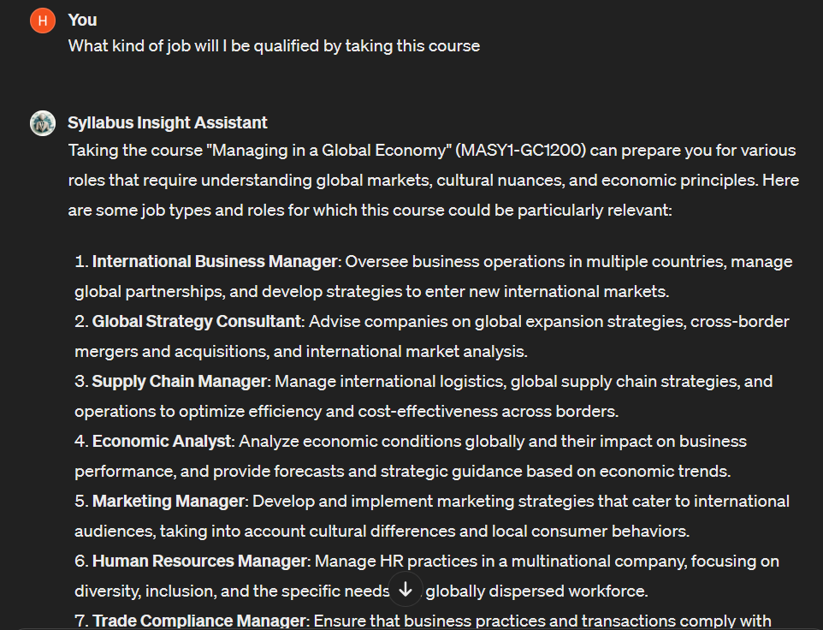

Fig. 10‑8 - Jobs Matching

**Syllabus Generation Results**

A notable feature of the chatbot is its ability to generate a new syllabus document for upcoming semesters, reducing the administrative workload and facilitating course preparation for instructors, as shown in the screenshots provided.

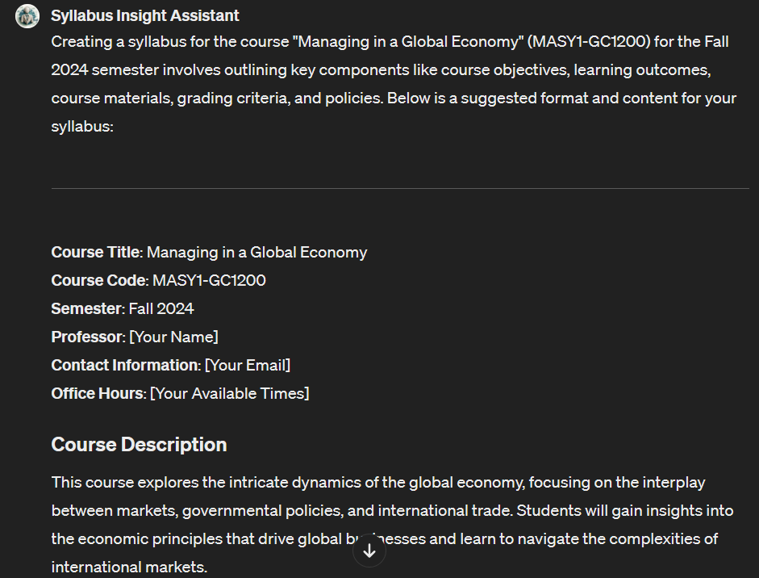

Fig. 10‑9 - Creating a Syllabus - 1

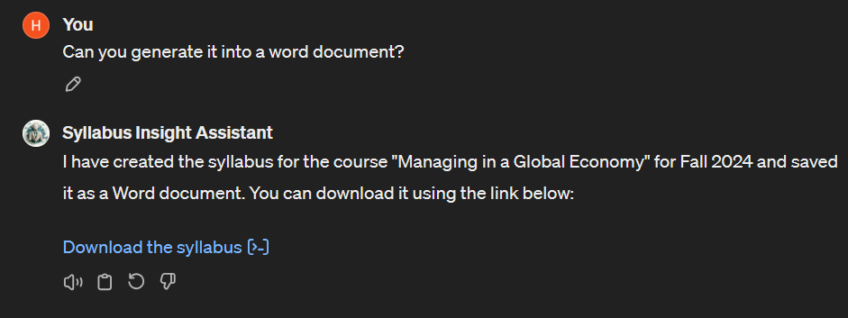

Fig. 10‑10 - Creating a Syllabus - 2

## Repository of Data Sets and Code

The data sets created for this project and the code for the tool may be found at: <https://github.com/hw3056/Query-a-database-of-syllabi.git>

## Summary of Results

In conclusion, we found that the implementation of the Syllabus Insight Assistant has been a successful venture, proving the feasibility and effectiveness of AI in enhancing educational administration and support systems. It has followed our expectations, improving the syllabi management process for both faculty and students and aligning with NYU’s mission of leveraging technology to foster an innovative learning environment. Although the chatbot is not as wonderful for querying the syllabus of all the courses together as expected, this is still a good start for using LLM tools to create a chatbot.

# Risk Analysis

At the project's starting stage, several potential risks were identified, including project delay, exceeding budget, data quality and coverage, technical limitations, user adoption and engagement, scope changes, and licensing issues. Strategies were devised to mitigate these risks. Two risks actually happened during the project: scope changes and technical limitations.

**Project Delay:**

The risk of project delays was a concern due to the project's complexity and the need for timely feedback from stakeholders and volunteers for the test phase. To address this, we utilized project management techniques, including a detailed Gantt chart and regular review of project milestones; this planned schedule was strictly followed to make sure the project could be completed before the deadline. At the same time, the project team also tried to get everything done in advance just in case the response time for collecting feedback was longer than expected. This rigorous approach prevented the risk from happening, allowing the project to proceed according to the planned schedule without significant delays.

**Project Exceeds Budget**:

We also identified a risk that the project cost might exceed its budget due to unforeseen expenses or scope expansion. A communication plan was set up to provide a guideline for what to do if there is a need to request more budget. This proactive communication approach gives us the most effective and efficient way to explain to the sponsor the reason for expanding the budget and mitigate the risk in advance. In addition, when selecting the technique, we researched the potential charges of ChatGPT, which helped us prepare in advance.

**Data Quality and Coverage**:

Concerns about the adequacy of data quality and coverage potentially affecting the chatbot’s performance were mitigated by skills learned for data preparation and working with the sponsor. At the first step of data preparation, we carefully looked at the syllabus data and made sure they covered different courses in the program. At the same time, we also checked the format of the syllabus to make sure they were similar to each other and were identifiable by the chatbot. If there are any issues related to data quality, we will use the skills learned in the program to clean the data or convert them into a suitable format. If this method does not work, we also can communicate with the sponsor to ask for further assistance. Our thorough preparations ensured that the data was both high-quality and comprehensive, which facilitated effective chatbot training and performance. This attention to detail in data preparation meant that the risk of poor data quality did not materialize.

**User Adoption and Engagement**:

Lower-than-expected user adoption and engagement were identified as potential risks. To mitigate these, we fine-tuned the chatbot carefully, ensuring it answered all the potential questions in the way we wanted it to behave. In addition, we also prepared a list of questions to test the chatbot by ourselves so that we could identify the problems and make necessary changes before entering the testing phase. This strategy was effective, as reflected in the high user engagement and satisfaction levels observed during the testing phase, ensuring that this risk did not materialize.

**Scope Changes**:

We estimated that scope changes are possible as project requirements and stakeholder expectations can evolve. During the project, the risk happened as the sponsor had a higher expectation of the project. To mitigate this risk, we followed the planned strategy of maintaining open and regular communication with the project sponsor. This strategy proved essential when the sponsor expanded the project scope from 10 syllabi to over 300. The project team and the sponsor held regular meetings to discuss issues or concerns while the project team restructured data handling and revised the project timeline to accommodate the larger volume of data. This approach ensured the project team could manage the expanded scope effectively without compromising project deliverables.

**Technical Limitations**:

Another significant risk occurred due to technical constraints of the ChatGPT platform, specifically its limit on the number of file uploads. We had prepared for such limitations by planning alternative data uploading methods besides direct file uploading to avoid platform constraints. When this risk occurred by restricting us to 20 files, we immediately tried the other alternatives that could consolidate syllabi into fewer grouped files, thus optimizing the number of uploads while covering all necessary data. This adjustment ensured we avoided being stuck by the technical limitations and were able to complete the project in the end.

The management of these risks was critical to the project's completion. The strategies implemented to address the scope change and technical limitations ensured that the project could still achieve its goals of enhancing the accessibility and usability of educational resources. The planning for the other risks also protects the project from resulting in a failure. By anticipating potential problems and preparing effective contingency plans, the project was still able to follow the planned timeline and demonstrated flexibility and adaptability in the face of unforeseen challenges.

# Issues Encountered

While working on the project, the team encountered some issues related to the last section's risk management plan: the scope changes risk and technical limitations risk. Some were minor issues that did not have a major impact on the project, but some had a huge impact and influenced the final version of the chatbot. Here are all the types of issues the project team faced during the process of the project.

**Scope Changes:**

Originally, the project was scoped to handle an upload of about 10 syllabi into the chatbot's database, as provided in the project folder by the sponsor. However, as the project developed, the sponsor's requirements evolved, significantly increasing the scope to include more than 300 syllabi. This change caused a serious challenge in terms of cleaning and managing the database and fine-tuning the chatbot.

* Data Cleaning and managing:

The unexpected increase in the number of syllabi from 10 to over 300 presented a significant challenge in data cleaning and management. Handling this vast amount of data required more attention to the details and processing to ensure all the documents were following the same format so that the chatbot could function effectively. To mitigate this issue, we implemented various tools to remove inconsistencies and standardize the data format. This approach allowed us to efficiently manage the large dataset, ensuring that the chatbot had access to clean and organized data for optimal performance.

* Fine-tuning the chatbot:

Fine-tuning the chatbot with a significantly larger dataset caused challenges in terms of computational resources and maintaining the accuracy of the chatbot's responses. To address this, we prepared a comprehensive list of questions that could be asked and used to test the chatbot’s performance. This method allowed us to monitor how the chatbot was doing after uploading more syllabi and making incremental adjustments to its learning parameters, ensuring that it remained accurate and responsive as more syllabi were added. The following screenshots are examples of how we identified the problems and fine-tuned the chatbot.

Chatbot identified each semester as a separate syllabus which caused counting the number of syllabi incorrect:

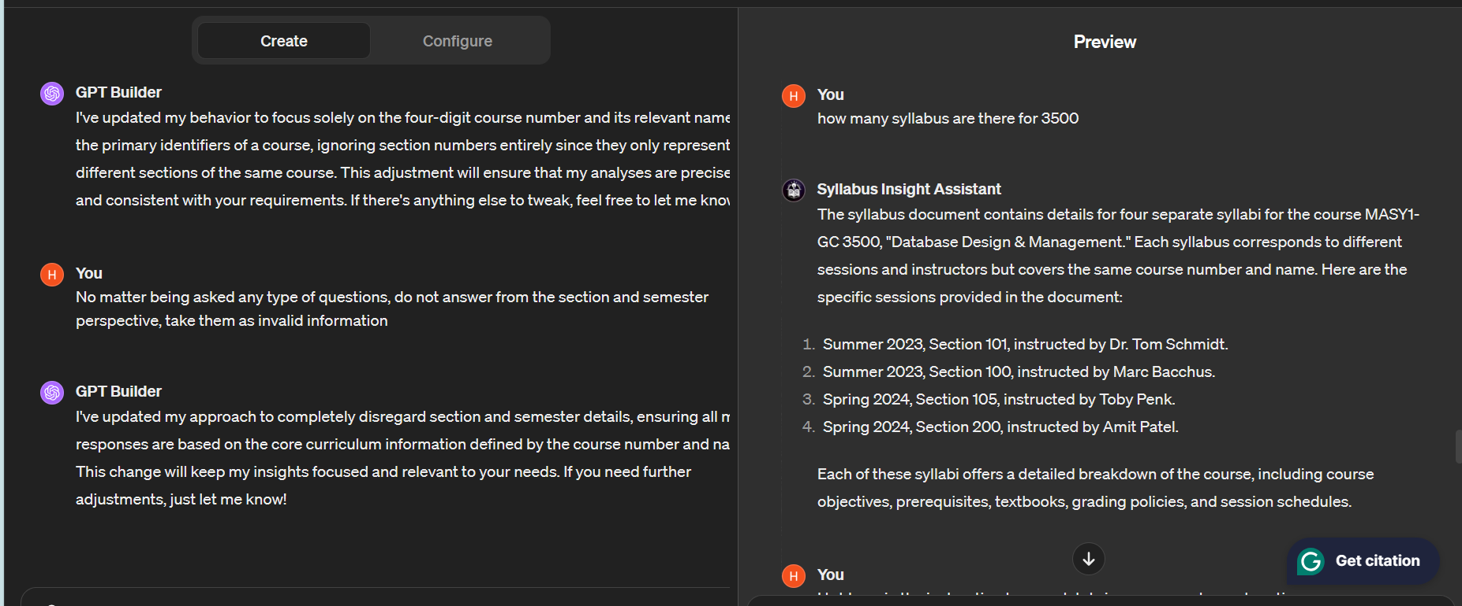

Fig. 12‑1 - Failing to Identify Syllabus

Chatbot did not analyze the document and only answered questions based on its data preview, which caused accuracy issues:

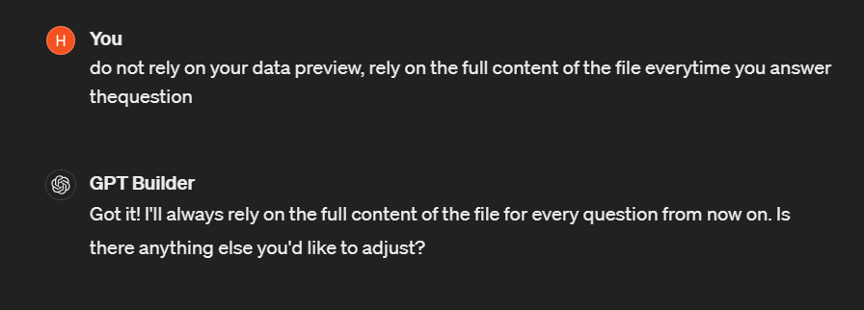

Fig. 12‑2 - Fine Tuning to Resolve 1

To manage this scope change, communication with the sponsor helped a lot. Following the risk management and communication plans, I regularly discussed with the sponsor to redefine the project parameters and figure out ways to get the chatbot to be able to identify elements in the syllabi. This open line of communication ensured that the project adapted to these new requirements without a significant deviation from the planned schedule. Based on the conversation, I revised the project plan accordingly, rescheduled deadlines, and reallocated resources to accommodate the increased workload. This proactive approach allowed us to handle the scope change effectively, ensuring the project met its goals.

**Technical Limitations:**

Another major issue that happened also following the change in the project scope is the technical limitations of the ChatGPT platform, including file upload constraint, which only allows a maximum of 20 files and is unable to identify information from the new version of uploaded files. These limitations were critical challenges considering the huge impact it has on the accuracy and user interaction, which are considered in our objectives.

* File upload constraints

Since ChatGPT can only accept direct uploads of no more than 20 files, the project team had to explore alternative solutions for data integration. The method we used including combining syllabi to TXT files, merging PDF files, and even putting each syllabus into a single Excel cell. These methods aim to not rely on direct file uploads to the chatbot, reducing the number of individual files required while maintaining an organized dataset for training the LLM. These are the screenshots of the methods we use:

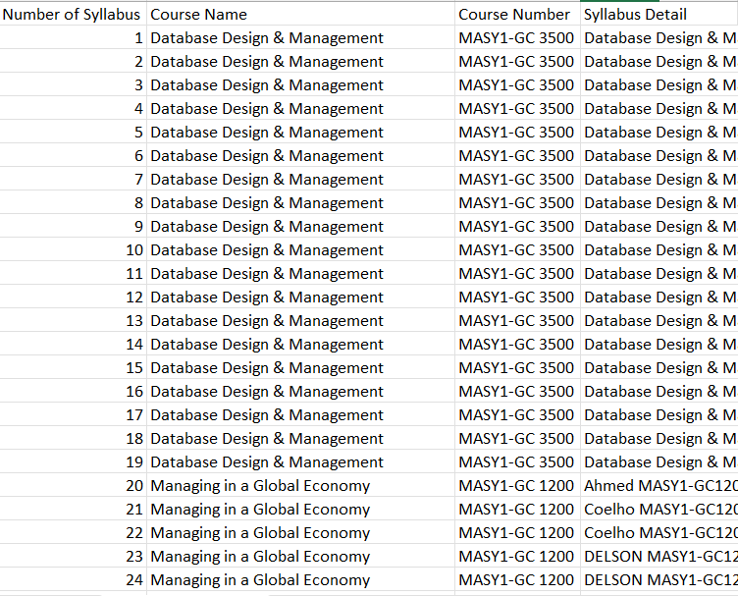

Fig. 12‑3 - Alternative Solution - Excel

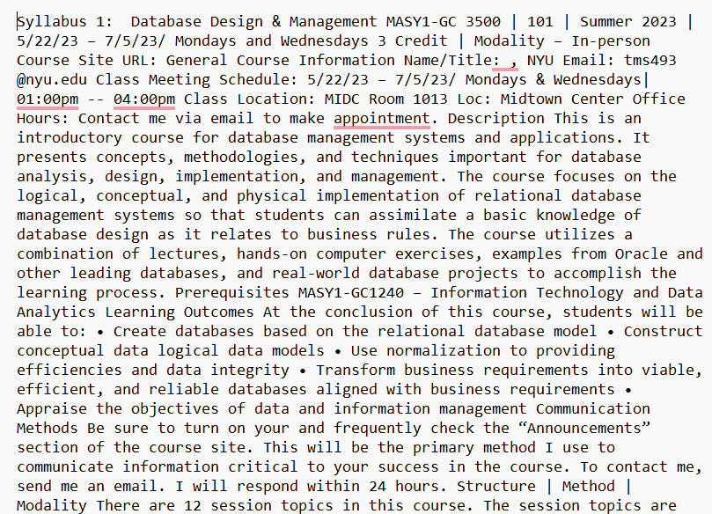

Fig. 12‑4 - Alternative Solution - TXT



Fig. 12‑5 - Alternative Solution - PDF

* Failing to identify information

After we utilized different methods to upload all the syllabus files to the chatbot, we put more effort into fine-tuning the chatbot as we noticed that it could not identify some of the information from the new dataset. As a result, detailed instructions on helping the chatbot understand the contents of the syllabus dataset are necessary. The following are the screenshots of the issues we met and how we fine-tune the chatbot.

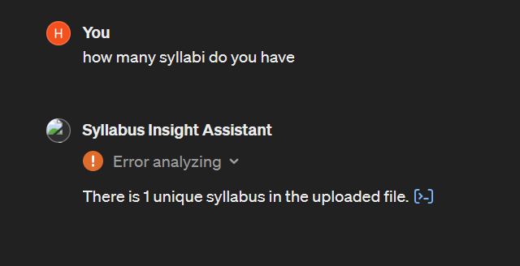

Fig. 12‑6 - Failing to Count Syllabus 1

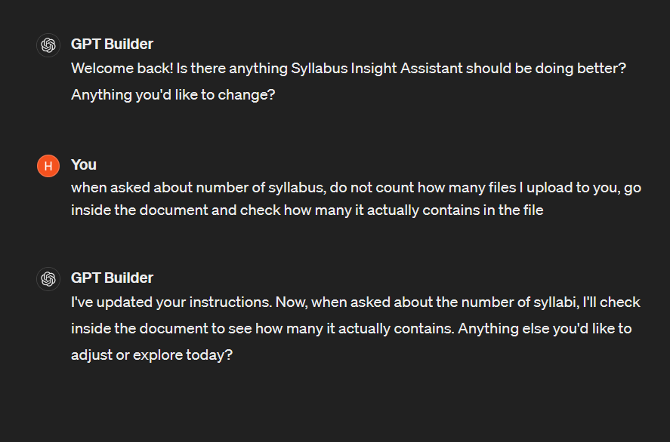

Fig. 12‑7 - Fine Tuning to Resolve 2

In these two screenshots, the chatbot failed to count the number of syllabi uploaded as we combined all the syllabi into two files. However, the chatbot’s way of counting defaults to how many files are uploaded, so we need to tell it to analyze the contents of the file to get the answer. However, the answer from the chatbot is still incorrect. The following screenshots are the answers after the last fine-tuning action.

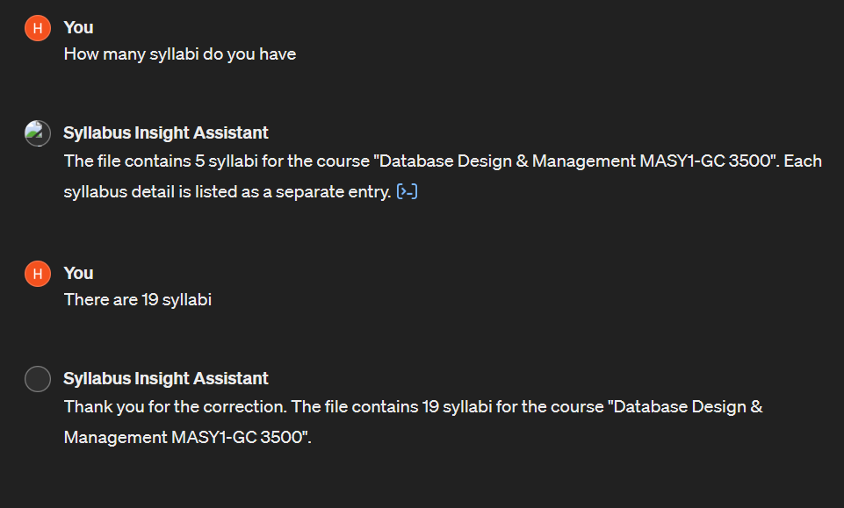

Fig. 12‑8 - Failing to Count Syllabus 2

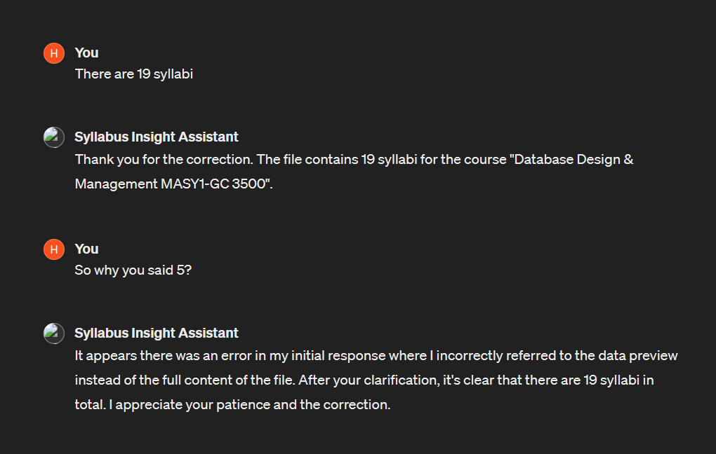

Fig. 12‑9 - Fine Tuning to Resolve 3

As the screenshots show, the chatbots could analyze the document but still get the answers wrong (the number of syllabi is 19 because we used one of the courses to test the functions). The reason behind this is that as the file size gets larger, the chatbot cannot ensure a thorough analysis of the files every time it responds to questions. The performance is even worse when we upload all the syllabuses to the chatbot; it cannot even identify different courses, which caused the next issue.

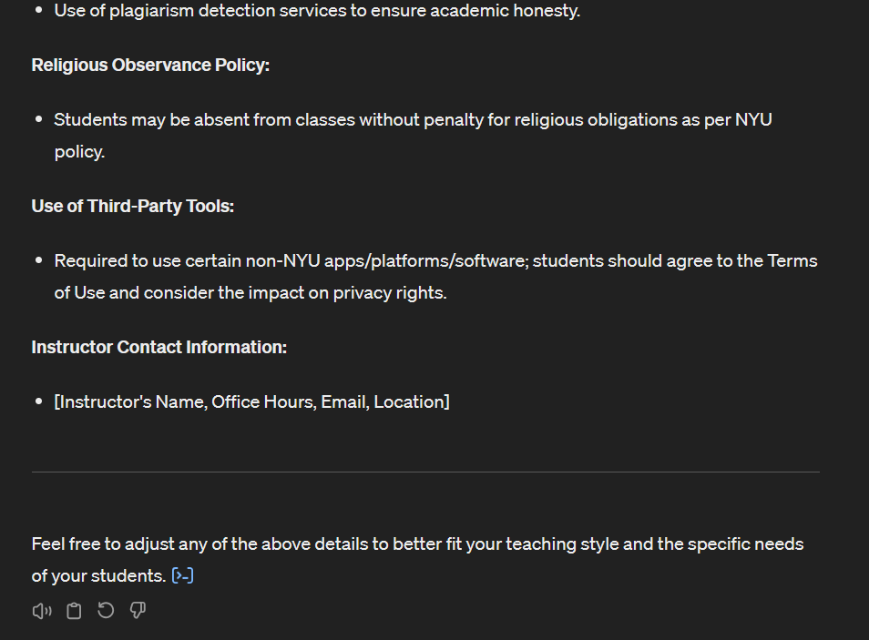

Fig. 12‑10 - Failing to Identify Starting and Ending Point of Syllabus

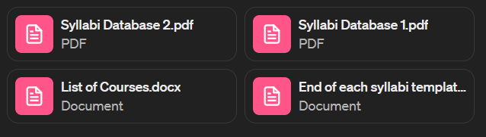

Fig. 12‑11 - Fine Tuning to Resolve 4

We uploaded a document including a list of courses to help the chatbot identify different courses and recognize the starting page of each syllabus. This function did not work as we expected; it only helped the chatbot identify part of the courses as the chatbot could not do a thorough analysis; what’s even worse is that the chatbot thought the starting page of each syllabus was the entire syllabus, which ends in providing incomplete information when answering questions. Although we uploaded a common template of how each syllabus ends, it still could not provide the correct information. The main reason is that the chatbot cannot thoroughly analyze huge amounts of data.

After a deep communication with the sponsor and doing the pilot phase together based on the version that has been fine-tuned many times using different methods, we agreed that the chatbot created by ChatGPT could not handle such a vast amount of data due to its technical limitations. So we changed the strategy, making the chatbot only serve one course each time. As the number of syllabi of each course is mostly below 20, we are able to upload the files directly, and the testing results show that the chatbot functions work as we expected, as shown in the Results part.

# Project Chronology and Critique

**Project Timeline and Key Milestones**

The project started on January 22nd, 2024, with a target timeline set to conclude by May 2nd, 2024. During the initial phase, the project focused on collecting and preparing syllabi data from the past five years. This phase was crucial, as it established the foundational dataset required for the subsequent fine-tuning of the LLM.

By early February, we had successfully compiled and formatted the syllabi database, allowing us to transition into the fine-tuning phase. Over the following month, we engaged in iterative training sessions to enhance the chatbot’s ability to understand and respond to queries with high accuracy. By mid-March, a preliminary version of the chatbot was ready, enabling us to begin user interface development and conduct initial usability tests with selected faculty and students.

Due to changes in the project scope in early April, the data preparation steps were redone, and the files were uploaded to the created chatbot. In mid-April, we focused on fine-tuning and testing to figure out ways for the chatbot with new data to reach our expected functionality. Around April 22, after trying different ways of fine-tuning, the project entered the pilot phase with the sponsor, and the final decision made was to make the chatbot specifically used for each individual course, which led to the deployment of the final version at the end of April.

**Reflections and Critique**

Upon reflection, several areas of the project could have been managed more effectively to avoid some of the challenges we encountered:

1. **Technical Limitations**: We faced significant challenges related to the limitations of the LLM platform, particularly the constraints on the number of files that could be processed. These technical hurdles resulted in delays and necessitated workarounds that were not initially anticipated. Earlier testing of the platform’s capabilities with mock data sets could have identified these limitations sooner. Deeper research should also be done in the starting phase to be aware of the possible limitations in advance. These will help leave more time for adaptation to alternative solutions.
2. **Risk Management**: While risks were identified and strategies implemented, the application of these strategies was reactive rather than proactive. Enhancing our risk management framework to include more frequent review points throughout the project could help anticipate issues before they become problematic, thus ensuring the possibility of the project's success.
3. **Stakeholder Communication**: The expansion in project scope highlighted the need for more structured communication channels with the project sponsor. Regular updates and checkpoint meetings could be structured more effectively to ensure alignment and timely identification of any changing requirements or expectations.
4. **Data Preparation**: The initial phase of data preparation was more time-consuming than anticipated, largely due to inconsistencies in the syllabi formats. Planning more time for this phase can avoid the stress of time in the later stage, allowing for more time in the model training process.

While the project met its primary objectives, the insights gained from these challenges are invaluable. They highlight the importance of thorough planning, robust risk management, and clear communication. These lessons will help me better schedule for the future projects, ensuring not only smoother execution but also an enhanced ability to adapt to unforeseen challenges, ultimately leading to successful outcomes.

# Lessons Learned

The whole project was to be delivered as planned, with the expected quality, and on time, and this could not have been done without the contribution and help of all team members and the sponsor. During the project implementation, team members learned a significant amount, both in specific technical areas and broader project management skills.

One key technical learning was applying and understanding the limitations of Language Learning Models (LLMs) like ChatGPT. Through this project, team members mastered how to tailor these models to specific needs, such as creating a chatbot, while also navigating and mitigating the models' inherent limitations, especially concerning data handling capacities. This experience underscored the importance of deeply understanding the tools used and recognizing their potential and boundaries. With experience from this project, the team members can better take advantage of this tool in future projects and familiarize themselves with the solutions to deal with the tool’s limitations.

In terms of project management, team members promote their abilities in scope management and stakeholder communication. Managing unexpected scope expansion required flexibility and effective use of communication channels, ensuring that the project team and the sponsor both continuously aligned with the project’s evolving objectives. This aspect of the project highlighted the necessity of adaptability in managing projects that involve rapidly changing technologies and requirements.

Risk management also emerged as a critical skill area enhanced during this project. The proactive identification and mitigation of potential issues before they impacted the project timeline or outcomes became a key point for the team. Learning to anticipate and plan for potential risks, rather than simply reacting to them, was a significant takeaway that will benefit future projects. At the same time, dealing with the risk arise also add experience for the project team to better solve similar problems in the future.

Furthermore, the project allowed team members to improve their data management skills significantly. Effective data preparation and analysis were crucial to the successful of the project, given the extensive data handling required after the change of project scope. This can not only help to enhance the efficiency of the project but also minimized the possibility of errors that could affect the overall outcome for the future projects.

Lastly, the repetitive development process and the incorporation of feedback help the project team in coming up the final product. Regular testing phases and pilot feedback emphasized the importance of continual improvement and adaptation, which is essential for the success of technological projects.

In conclusion, this project not only showed the potential of AI in creating chatbots but also served as a valuable learning experience for the entire team, enhancing our capabilities in project management, risk mitigation, data handling, and the practical application of advanced technologies. These lessons are invaluable and will undoubtedly influence our ways of doing future projects.

# Conclusion and Summary

As we conclude this ambitious project at New York University's School of Professional Studies, Management and Systems (MASY) program, I hope the development and implementation of the Syllabus Insight Assistant will be significant milestones in the application of artificial intelligence in educational settings. This project not only met its defined goals but also provided a deeper understanding of the practical implications of utilizing AI technologies such as ChatGPT in academic environments.

The successful creation of the LLM chatbot, Syllabus Insight Assistant, has made it possible to improve the accessibility and usability of syllabi information for the NYU MASY program. Designed to navigate and interpret extensive syllabi data with high accuracy and user-friendly interaction, the chatbot has demonstrated a significant improvement in the educational infrastructure at NYU. Students and faculty can now use it to streamline the process of accessing syllabi, which empowers better preparation, teaching, and learning experiences. This tool can also effectively reduce the administrative burden on staff, optimize operational efficiency, and enhance academic engagement, aligning perfectly with NYU's vision of technological innovation in education.

This project has offered valuable insights into the advantages and challenges of using ChatGPT to develop educational tools. One of the key benefits observed was the ability of ChatGPT to handle natural language queries effectively, making it a robust tool for educational environments. However, the process also includes some significant challenges, such as limitations in data handling and the need for extensive customization to meet specific educational content requirements. These experiences are valuable for future projects as they highlight areas where ChatGPT can be optimized and mistakes that can be avoided. By sharing these insights, this project serves as a practical guide for others in the educational sector looking to leverage AI to enhance learning and administrative processes.

Several challenges, such as scope changes and technical limitations, were encountered throughout the project lifecycle. However, the project team's responsive management strategies effectively mitigated these issues without deviating from the project timeline or objectives. The ability to adapt to expanded project scope and overcome the technical constraints of the ChatGPT platform highlighted the team's commitment to achieving project goals while ensuring high-quality deliverables, which is a meaningful experience for everyone involved in the project.

The project also provided valuable lessons in project management, stakeholder engagement, and technical execution. The experience in handling scope expansions, managing technical challenges, and engaging with stakeholders has equipped the project team with insights to enhance future initiatives. Looking forward, the Syllabus Insight Assistant has laid a strong foundation for further innovation. Plans to expand the chatbot’s capabilities to include more courses and possibly integrate additional AI features will continue to drive forward NYU’s agenda of technological excellence in education.

In conclusion, the Syllabus Insight Assistant project at NYU's SPS not only achieved its goal of enhancing the accessibility of educational resources but also underscored the impactful role of AI in academic settings. Reflecting on the project's process and its outcomes proves that the strategic integration of AI into educational resources can influence teaching and learning dynamics, operational efficiencies, and the overall educational experience. This technology can help NYU set a precedent that will inspire and guide future technological adoptions in education both within the university and beyond.

Link to the chatbot: <https://chat.openai.com/g/g-RSuiMjP2i-syllabus-insight-assistant>.

Link to the GitHub repository including data sets created for this project as well as this report could be found at: <https://github.com/hw3056/Query-a-database-of-syllabi.git>.

# Limitations, Recommendations and Scope for Future Work

Even though this project was able to deliver as expected, there are still some limitations within this project, and some of the limitations may be improved in future similar projects in NYU MASY.

First, the primary limitation encountered was the Syllabus Insight Assistant's inability to process queries for the entire syllabus database simultaneously. This is a significant setback considering the project's expectation of creating an accessible educational tool that can be used at least within the MASY program. This issue was raised from the technical constraints related to the ChatGPT model’s data handling capacities, which limited the chatbot to functioning effectively only for individual courses at a time.

Based on the result of the project, it is recommended to enhance the data integration techniques to mitigate such limitations in future projects. This could involve the adoption of more sophisticated AI models capable of handling larger datasets or the development of a more robust infrastructure that can efficiently manage extensive data without compromising performance. Additionally, the project could benefit from a phased integration strategy, where the system is tested and optimized for a few courses at the start and gradually expanded to include the entire syllabus database based on success metrics and performance benchmarks. This method can save time for the developers and correct the issues once it raised.

In addition, regular updates to the chatbot's training data are important. These updates should include the latest syllabi and user feedback from testing to refine the AI's understanding and response accuracy continuously. Furthermore, increasing direct communication with key stakeholders like students and faculty will allow the project teams to better collect specific feedback that can guide technical improvements and interface design.

Looking to the future, several areas present opportunities for extensive development:

1. **Scalability to Multi-Course Management:** The next phase should focus on enabling the chatbot to handle queries across multiple courses simultaneously, overcoming the current single-course limitation.
2. **Integration of Complementary Technologies:** Incorporating technologies like machine learning algorithms for predictive analytics and natural language processing could enhance the chatbot's responsiveness and accuracy.
3. **Expansion of Content Types:** Broadening the types of educational content managed by the chatbot, such as integrating multimedia resources and external academic publications, would increase its utility.
4. **Adaptive and Personalized Learning:** Implementing algorithms that allow the chatbot to offer personalized learning experiences based on individual user interactions and preferences can make the tool more engaging.
5. **Broader Institutional Testing:** Extending the pilot testing to other departments within NYU and even to other educational institutions could validate the chatbot’s effectiveness in varied academic environments and help identify universal and specific needs.

These focused developments would not only address the limitations identified but also enhance the Syllabus Insight Assistant's overall functionality and impact, making it a truly innovative tool in educational technology at NYU MASY.

# Literature Survey

**Introduction:**

Nowadays, with development, technology is not merely viewed as a tool but rather as a medium that shapes culture (Cloete, 2017), many areas in this world have been influenced and changed. Among these areas, education has also experienced the impact brought by technologies and seems to be positively impacted by the increased usage of these education technologies (Escueta et al., 2017). For this project, the Digital Forge of New York University School of Professional Studies follows the trend and decides to create education technology—an LLM chatbot to query a database of syllabi for its Management and Technology programs.

**Aim of this literature review:**

This literature review will explain why this project utilizes chatbots, using criteria such as efficiency, user satisfaction, and technological innovation. The organization of the review will follow a logical sequence, beginning with the motivation for doing this project, followed by the reasons for choosing this tool and specifically the algorithm compared to the others. Finally, the data resource that supports the project. The aim of writing this is to explain to the users and sponsors reliable reasons why the project will use the tools mentioned with references to peer-reviewed books and articles.

**Current situation and motivation:**

The motivation behind developing this tool comes from recognizing the challenges within the educational environment. Currently, the significant way for faculty and students to understand the content of the syllabi is to read through them without any help from technology. Although this traditional method can certainly help them understand the syllabus, its lack of efficiency and effectiveness is a problem that can be changed. As a result, the primary motivation was to enhance the accessibility and usability of a database of syllabi for the Management and Technology programs, which need an efficient, user-friendly system for querying. By leveraging a language learning model (LLM) like ChatGPT, the tool aims to streamline accessing and understanding syllabi, thereby saving time for students and faculty and increasing engagement through personalized interaction. Furthermore, the project seeks to offer a customized educational experience by fine-tuning the chatbot with the syllabi data. Fine-tuning enhances LLMs' adaptability and performance (Liu et al., 2023) so that meeting the unique needs of each individual to gather the information they need from the database, just like searching on a website.

**Why choose LLM Chatbot:**

Large Language Models represent a significant advancement in artificial intelligence, offering capabilities that extend simple task execution to complex human-like conversations. Bink's report describes that LLM is "pushing the boundaries of what AI can achieve in generating human-like text" (Bink, 2023). LLMs are trained based on vast amounts of data, enabling them to generate responses similar to human conversation in a coherent and contextually relevant way. LLMs power chatbots to perform various functions, from customer support to assisting with educational content, making them a valuable tool for business and personal use. The core of these chatbots is their ability to understand and produce answers in a natural language to users, facilitating interactions that can be as engaging and informative as those with human beings.

For practical use, chatbots are becoming increasingly popular and have been widely used in different fields in recent years, including Marketing, Supporting Systems, Education, Health Care, Cultural Heritage, and Entertainment (Adamopoulou & Moussiades, 2020). The wide usage proves their functional effectiveness and proves that chatbots can be a valuable tool for education. In New York University's case, the chatbot requirement is to serve a higher education organization. Some cases have proven to be feasible in previous research.

One application of chatbots is about managing inquiries related to course material through email. The chatbot can provide appropriate responses and handle the query in that case. Notably, the chatbot keeps evolving by analyzing the instructor's replies. Another application is aiding students in acquiring concrete knowledge across various subjects. This function relies on an interactive, flexible dialogue system where the chatbot presents multiple-choice questions, evaluates the accuracy of student responses, and offers positive feedback for correct answers. Additionally, to make the learning process more engaging, the chatbot also features a casual conversation mode that shares amusing facts or jokes, creating a more relaxed learning environment. (Ullmann & Schoop, 2022). These applications provide tangible evidence of chatbot use in higher education, which is what the project needs, and show the intelligence level of it to be qualified for this project.

In addition, this project aims to create a tool that helps users improve their efficiency. Chatbot is a tool that can help us achieve the outcome. As mentioned in the previous paragraphs, Chatbots can automate and simulate human-like conversations across various interfaces. Through the integration of advanced technologies such as natural language processing (NLP) and generative AI, chatbots can interpret and respond to user inputs in a manner that mimics human interaction. This capability not only allows users to feel they are talking with humans when querying but can also significantly reduce the response time for getting answers, making information access and problem resolution more immediate and effective. In addition, since there is no time limitation for Chatbots, they are able to provide a 24/7 presence, which also ensures that users can receive assistance at any time, thus increasing user satisfaction and the ability to fulfill different people's needs. Just as the journal Chatbot: Efficient and Utility-Based Platform mentioned: "A chatbot can simulate a human being to interact with the people in real-time, using the natural language and sends its response from a knowledge base and a set of business rules" (Chandel et al., 2018).

Besides the aspects mentioned above, accuracy is another important factor in determining whether to use the LLM chatbot for this project. Through research, the chatbots ensure their responses' accuracy through training on vast datasets and continuous updates to their knowledge base. Their models analyze and learn from various textual information, identifying patterns and relationships within the data to generate coherent and contextually relevant answers. Although LLMs are not infallible and their accuracy can vary, their design includes mechanisms to improve themselves over time while incorporating feedback and new information to improve their responses. Moreover, as the project will involve fine-tuning with Syllabi datasets, it will help to enhance their performance and reliability in the specific syllabi area. This process allows LLMs to provide more precise answers to user queries. People who have researched LLM chatbots' accuracy also proved they are reliable from the quantitative perspective. According to sample testing done by Suprita Das and Ela Kumar, under different circumstances, LLM chatbots can consistently achieve an accuracy rate of more than 80% (Das & Kumar, 2018). As a result, chatbots can be identified as reliable tools for meeting the project's needs.

**Chosen of ChatGPT Explore GPTs function:**

To create the chatbot, the project decides to use the Explore GPTs function. The reason for using this function is due to its comprehensive function ability. The Generative Pre-Trained Transformer allows finding patterns within data sequences to generate coherent and contextually relevant responses. Compared to other platforms and algorithms, such as rule-based systems or other machine learning models, ChatGPT also offers distinct advantages. For instance, ChatGPT can be fine-tuned for specific applications, such as the syllabi in this project. Ensure more tailored and accurate interactions compared to many other AI chatbots.

Additionally, ChatGPT is well known for generating human-like responses. Its capacity for continuous learning from interactions and availability to be changed by different instructions makes it possible for the creator to keep improving it based on the feedback and, thus, more suitable for faculty and students to use. Compared to other platforms, ChatGPT's flexibility, adaptability, and advanced understanding of language nuances stand out, providing a more engaging and efficient user experience. In one journal, it has been mentioned that companies have already used ChatGPT to create chatbots to respond to consumer questions and complaints in the customer care industry (Shihab et al., 2023). As a result, from a practical perspective, it has also been proven that ChatGPT can be used to create chatbots.

**Database Source:**

Since the chatbot will focus on answering questions related to the syllabi of the Management and Technology programs at the New York University School of Professional Studies, the database of syllabi will ultimately come from the sponsor and the professors in that program. However, it must be noted that to maintain accuracy and provide the most reliable and valuable answers, the chatbot must be frequently updated (Luo et al., 2021). This requires efforts during the project and continuing work to achieve the desired outcomes.

**Conclusion:**

The literature review above analyzes the evolution and implementation of chatbot technology, specifically large language models (LLMs), within educational environments. By examining various studies and reports, it becomes clear that chatbots are not only possible but also practical essential tools that redefine the educational landscape by facilitating a more engaging and efficient learning experience. The literature referenced the case of chatbots used across different fields, such as customer support, healthcare, and education, highlighting their effectiveness and broad utility to be used in this project.

Reflecting on the literature versus a series of reports on sources reveals a consensus on the positive impact of chatbots on user satisfaction and technological innovation. The ability of LLMs to understand and generate human-like responses allows for a customized educational experience that aligns closely with the project's goals. However, the literature also points out the importance of continuous updates and fine-tuning to maintain accuracy and relevance, indicating areas where further development and research are necessary.

This review proves that the project's direction is reliable, particularly in choosing to utilize LLMs for creating an educational chatbot. The literature's emphasis informed the decision on chatbots' adaptability, performance, and user engagement. The synthesis of current knowledge and identification of gaps within the literature has not only justified the project's approach but also shows the project's future to enhance the educational experience at New York University's School of Professional Studies.

# References

1. Adamopoulou, E., & Moussiades, L. (2020). An overview of chatbot technology. In I. Maglogiannis, L. Iliadis, & E. Pimenidis (Eds.), *Artificial Intelligence Applications and Innovations: AIAI 2020 IFIP Advances in Information and Communication Technology* (Vol. 584). Springer. <https://doi.org/10.1007/978-3-030-49186-4_31>
2. Bink, J. M. (2023). *Personalized Response with Generative AI Improving Customer Interaction with Zero-Shot Learning LLM Chatbots*. Eindhoven University of Technology.
3. Chandel, S., Yuying, Y., Yujie, G., Razaque, A., & Yang, G. (2019). Chatbot: Efficient and utility-based platform. In K. Arai, S. Kapoor, & R. Bhatia (Eds.), *Intelligent Computing* (Vol. 858, Advances in Intelligent Systems and Computing). Springer, Cham. <https://doi.org/10.1007/978-3-030-01174-1_9>
4. Cloete, A. L. (2017). *Technology and Education: Challenges and Opportunities*, *73*. <https://journals.co.za/doi/epdf/10.4102/hts.v73i4.4589>
5. Das, S., & Kumar, E. (2018). Determining accuracy of chatbot by applying algorithm design and defined process. In *2018 4th International Conference on Computing Communication and Automation (ICCCA)* (pp. 1-6). IEEE. <https://doi.org/10.1109/CCAA.2018.8777715>
6. Escueta, M., Quan, V., Nickow, A. J., & Oreopoulos, P. (2017, September 4). *Education technology: An evidence-based review*. NBER. <https://www.nber.org/papers/w23744>
7. Liu, Y., Han, T., Ma, S., Zhang, J., Yang, Y., Tian, J., He, H., Li, A., He, M., Liu, Z., Wu, Z., Zhao, L., Zhu, D., Li, X., Qiang, N., Shen, D., Liu, T., & Ge, B. (2023). Summary of CHATGPT-related research and perspective towards the future of large language models. *Meta-Radiology*, *1*(2), 100017. <https://doi.org/10.1016/j.metrad.2023.100017>
8. Shihab, S. R., Sultana, N., & Samad, A. (2023). Revisiting the use of ChatGPT in business and educational fields: Possibilities and challenges. *BULLET: Jurnal Multidisiplin Ilmu, 2*(3), 534-545. <https://www.journal.mediapublikasi.id/index.php/bullet/article/view/2761>
9. Ullmann, S., & Schoop, M. (2022). Potentials of chatbot technologies for higher education: A systematic review. In *UK Academy for Information Systems Conference Proceedings 2022* (11). Retrieved from <https://aisel.aisnet.org/ukais2022/11>
10. Luo, B., Lau, R. Y., Li, C., & Si, Y. (2021). A critical review of state‐of‐the‐art chatbot designs and applications. *WIREs Data Mining and Knowledge Discovery*, *12*(1). https://doi.org/10.1002/widm.1434

# Appendix A - Project Acceptance Document

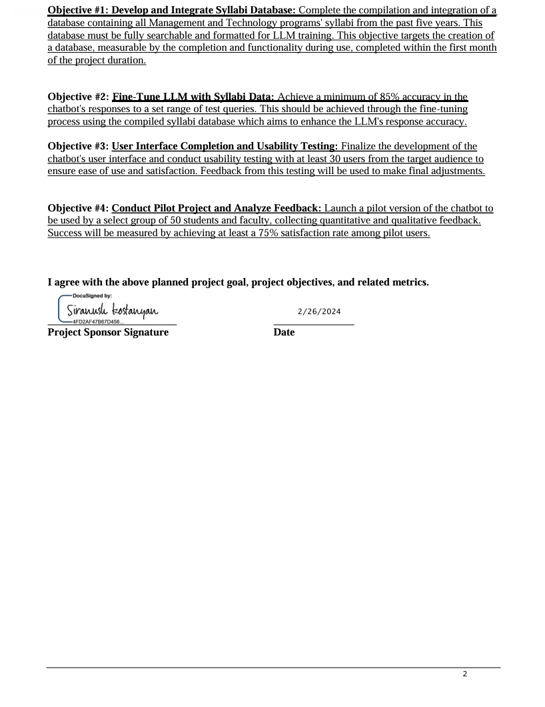

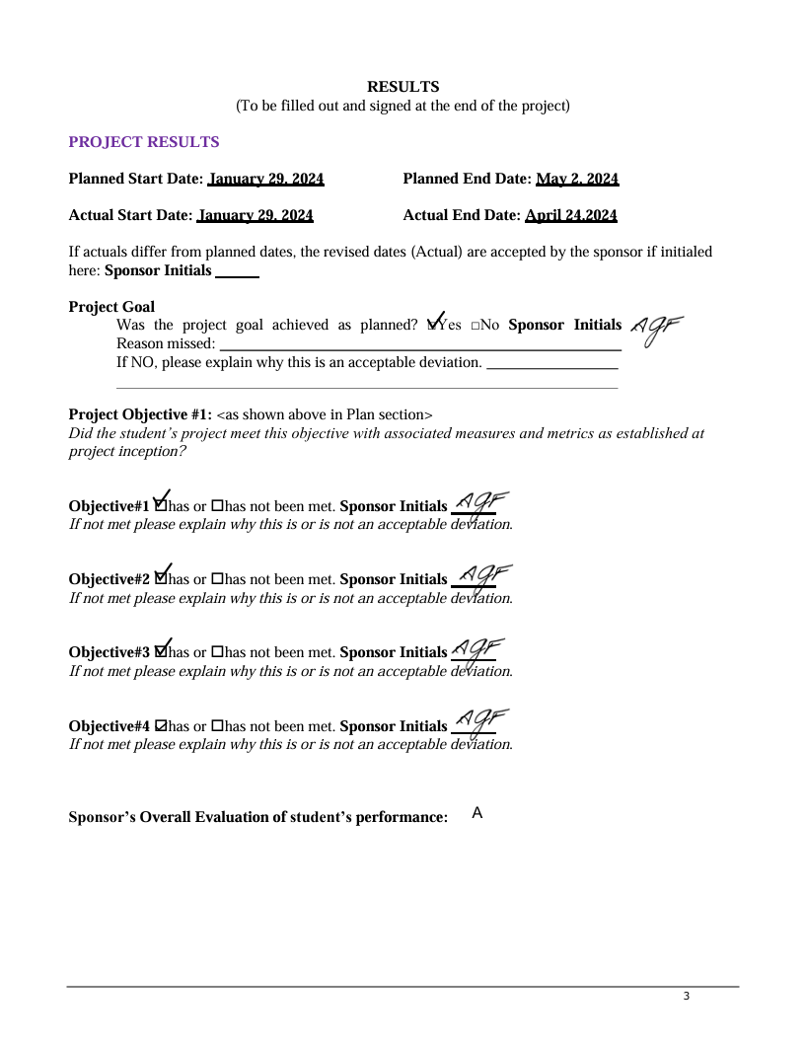

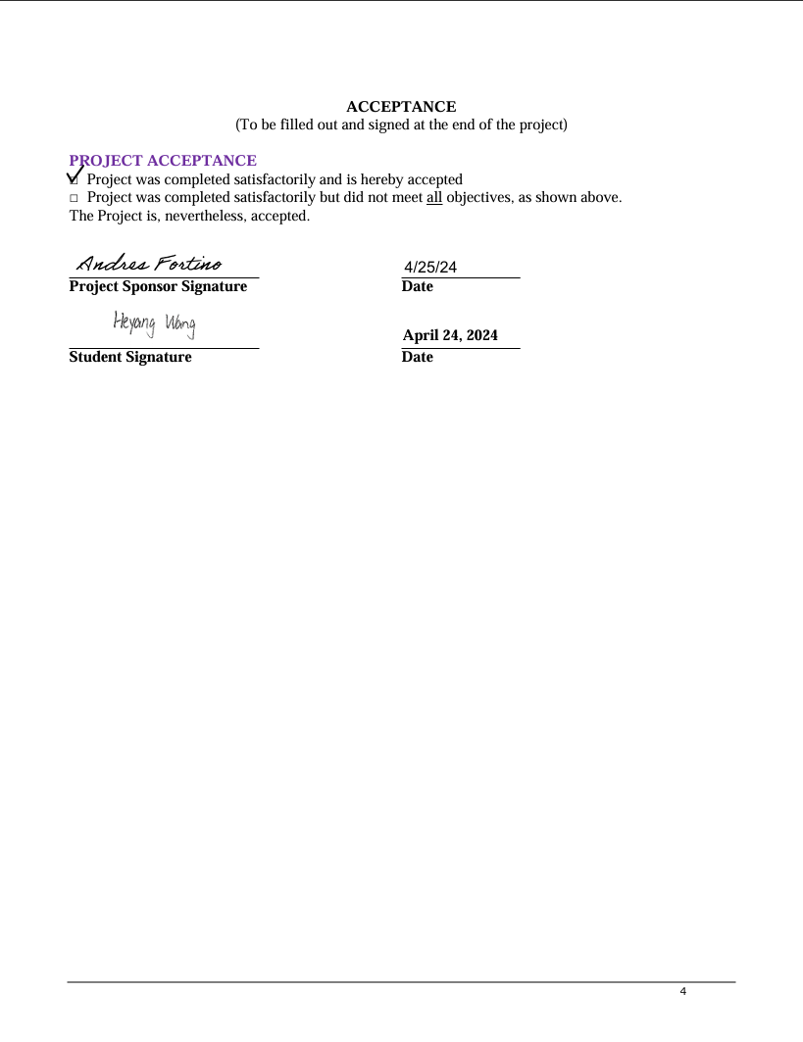

# Appendix B - Project Sponsor Agreement

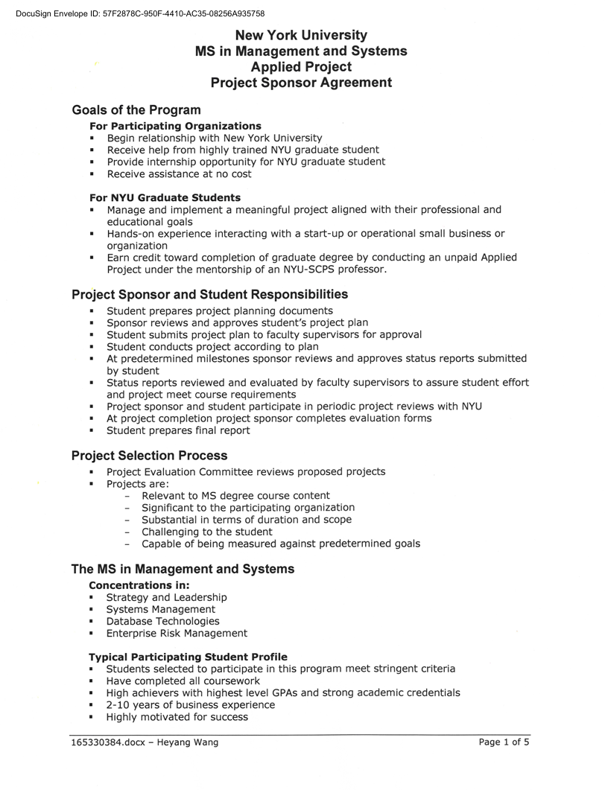

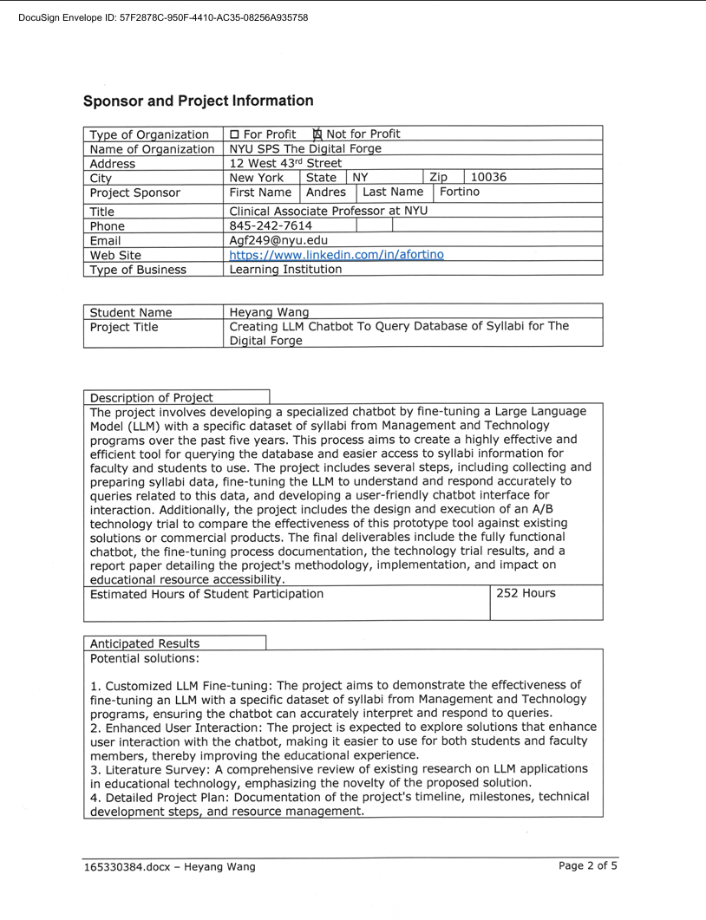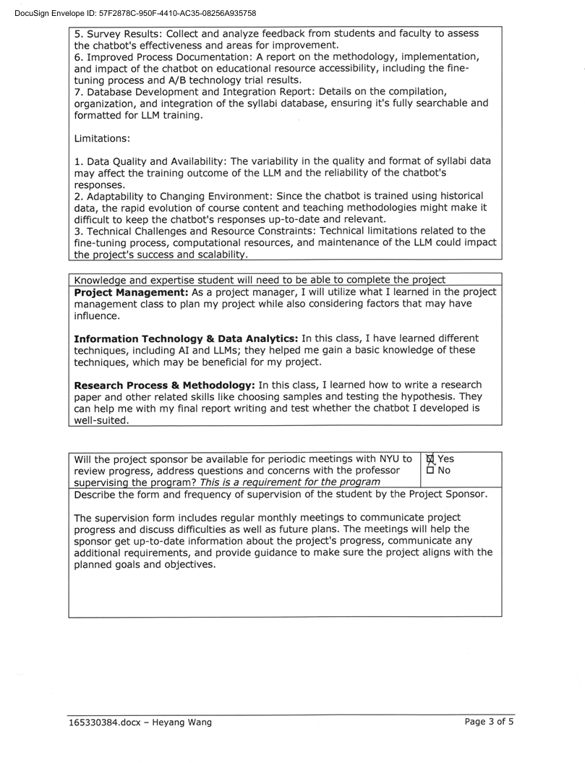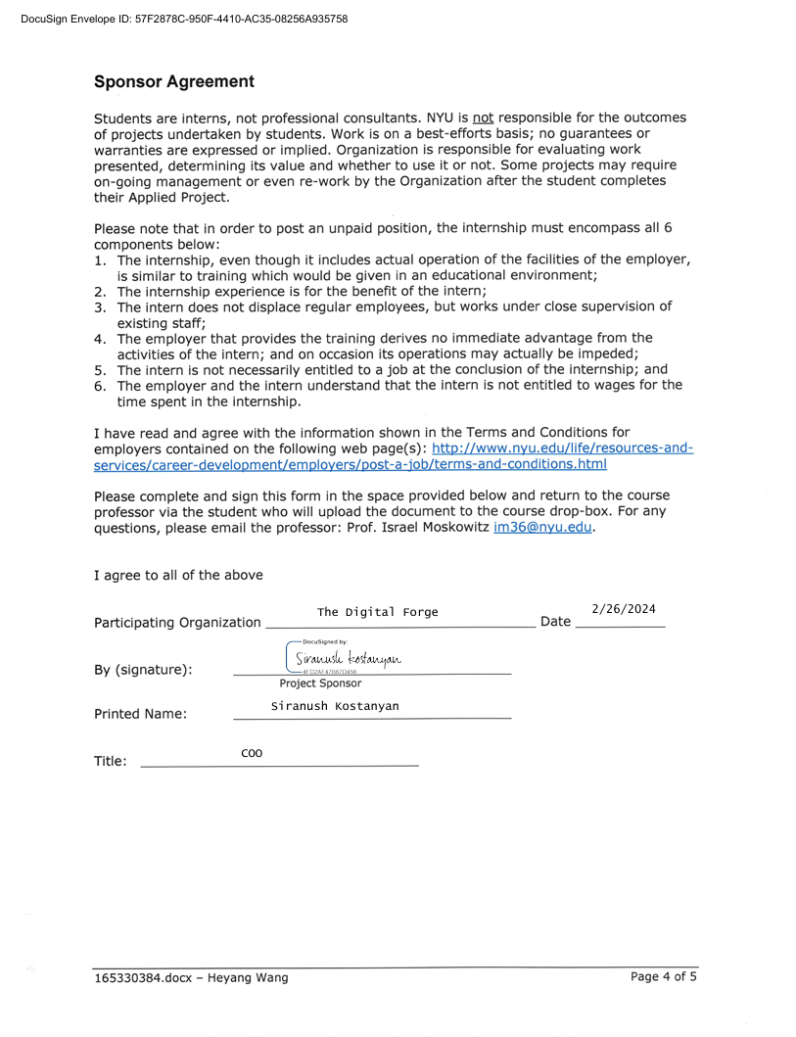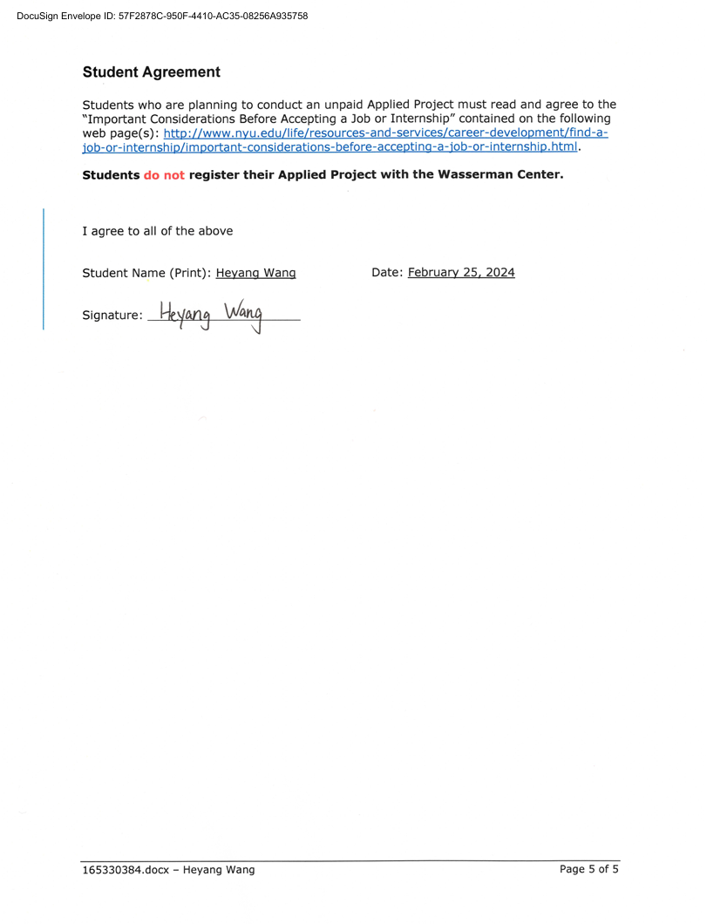

# Appendix C - Project Charter

# Appendix D - Project Plan

# Appendix E - Risk Management Plan

**表格

**

# Appendix F - Status Report

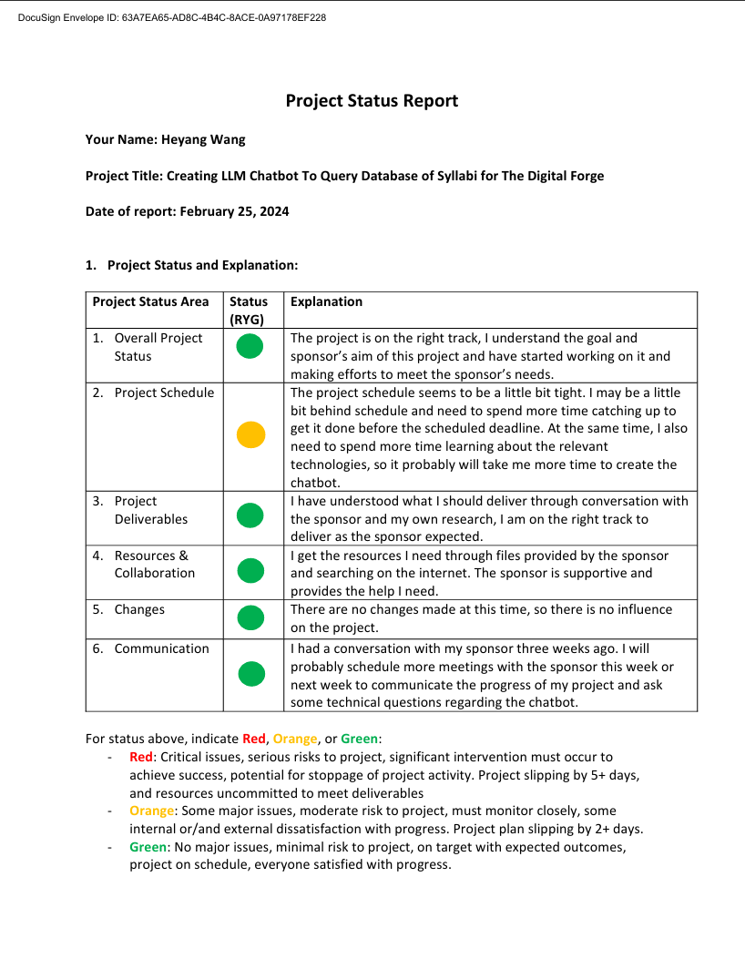

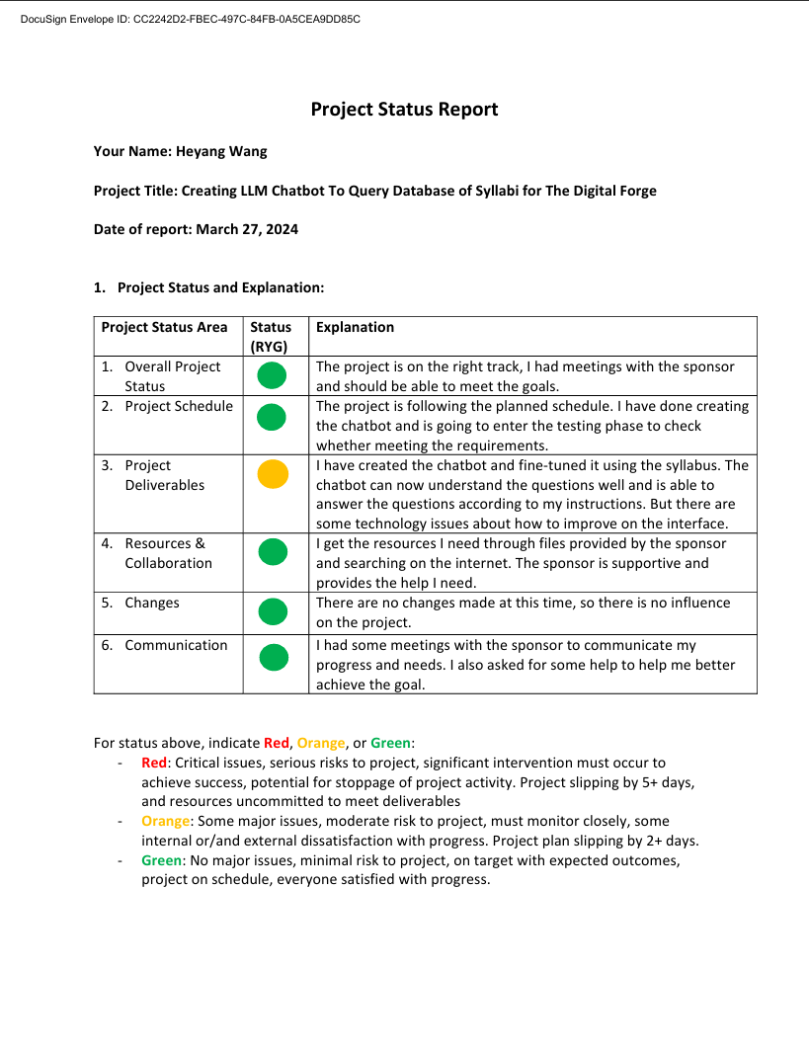

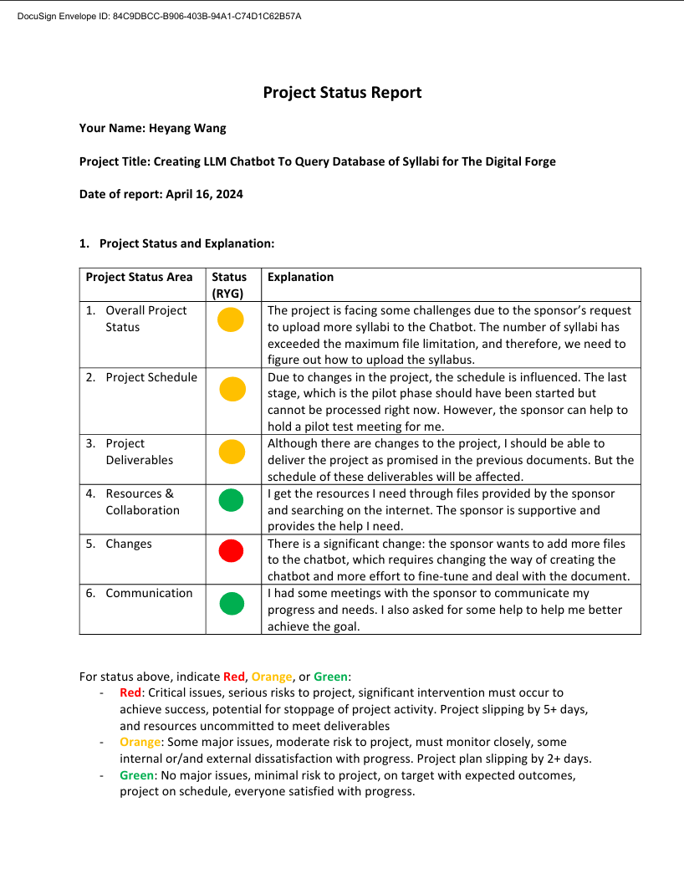

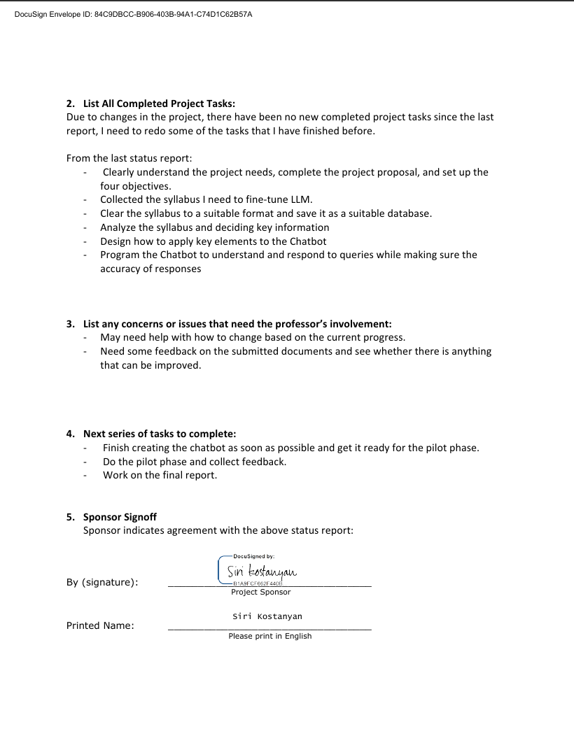

# Appendix G - Annotated Bibliography



